CS 581 – Spring 2023 – Assignment 1

You will solve a route-finding problem manually. Here are the roads and the costs between cities:

A – B: 4

A – S: 4

A – F: 5

B – C: 4

B – D: 3

D – E: 4

D – G: 5

E – F: 3

E – G: 2

F – H: 1

G – H: 5

I – J: 4

I – M: 6

I – N: 7

I – S: 6

J – K: 3

J – L: 3

J – S: 5

K – L: 3

L – W: 7

L – X: 8

L – Y: 9

M – N: 8

M – R: 5

M – T: 3

M – U: 4

N – O: 2

N – P: 3

N – Q: 4

The roads are bi-directional. For example, A – B = B – A = 4. Another example: it looks like you cannot go anywhere from S, because there is no edge that starts with S, but that would be an incorrect interpretation, because you can travel from S to A, or to I, or to J.The starting city is S; the goal city is G. Here is an h function.

h(A): 8

h(B): 4

h(C): 8

h(D): 2

h(E): 2

h(F): 5

h(G): 0

h(H): 5

h(I): 7

h(J): 8

h(K): 11

h(L): 11

h(M): 13

h(N): 14

h(O): 15

h(P): 17

h(Q): 18

h(R): 18

h(S): 10

h(T): 16

h(U): 18

h(W): 18

h(X): 20

h(Y): 20

1. [15 pts] Perform Uniform Cost Search traveling from S to G using the edge costs given above.Show the frontier, the explored, and the search tree, as was shown in class. Show the g values clearly in the frontier and in the search tree. What is the solution path found and what is its cost?

explor sort by ：

S A J I B K L F H D C M N E

The best solution path is S-A-F-E-G cost 14

The other nodes like ‘W,X,Y,R,T,U,O,P,Q’

The current node's cost (g) has reached more than 14, so there is no need to continue explored

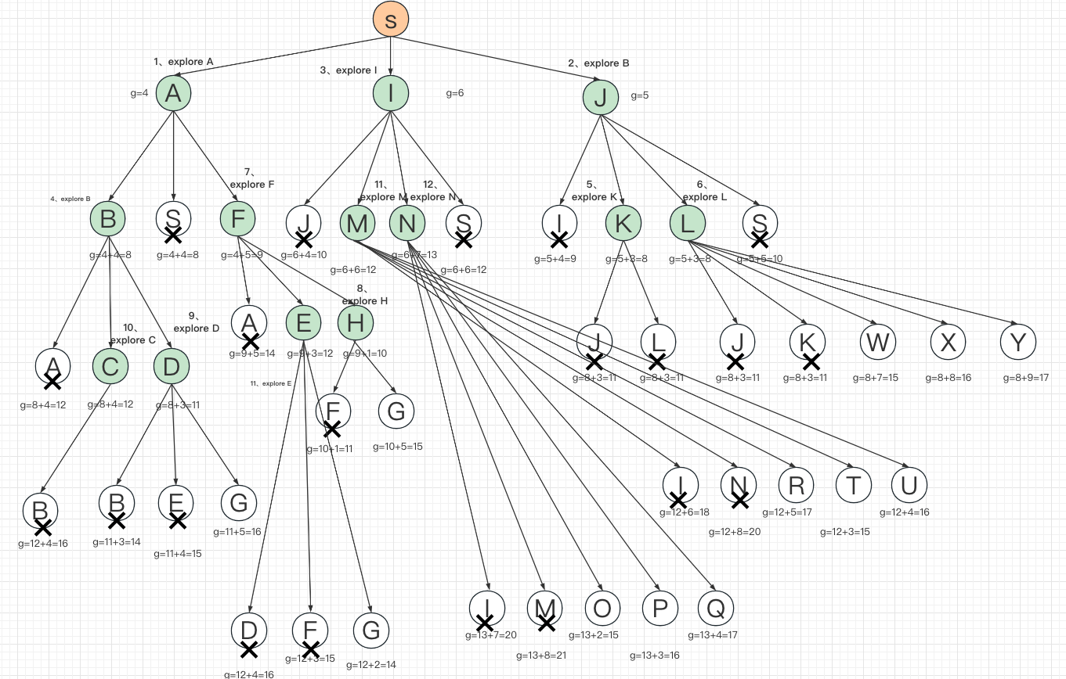

1. [15 pts] Perform heuristic-best-first search from S to G, using the h function above. Show the frontier, the explored, and the search tree, as was shown in class. Show the h values clearly in the frontier and in the search tree. What is the solution path found and what is its cost?

explor sort by ：

S I A B D

The best solution path is S-A-B-D-G

cost 16 cost(S->A)+cost(A->B)+cost(B->D)+cost(D->G)

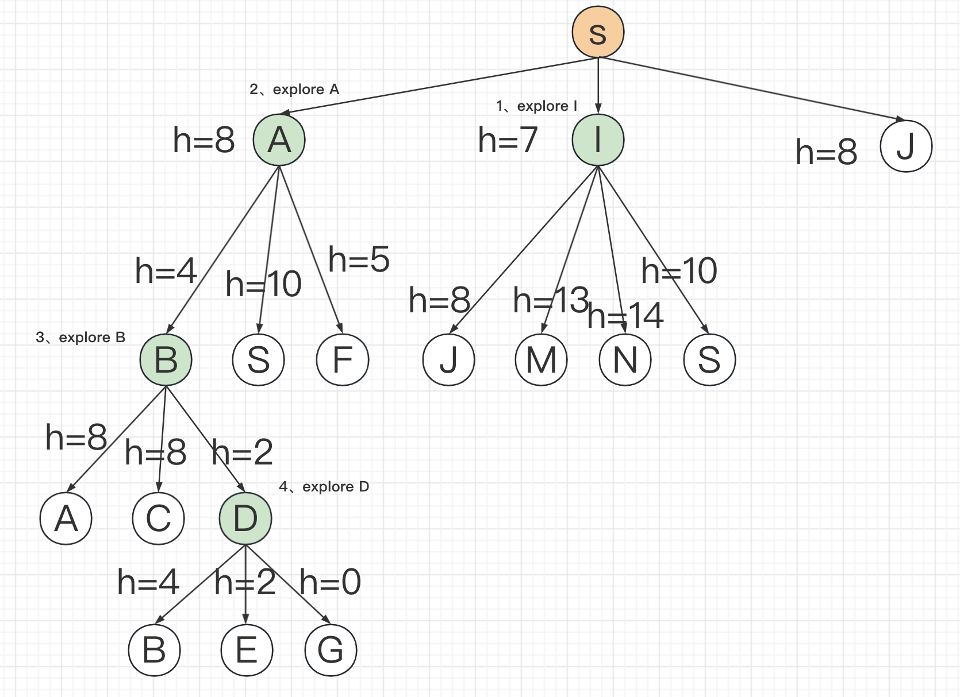

1. [20 pts] Perform A\* search from S to G, using the edge costs and the h function given above.Show the frontier, the explored, and the search tree, as was shown in class. Show the f values clearly in the frontier and in the search tree. What is the solution path found and what is its cost?

explor sort by ：

S A B D I J F E

The best solution path is S-A-F-E-G cost 14

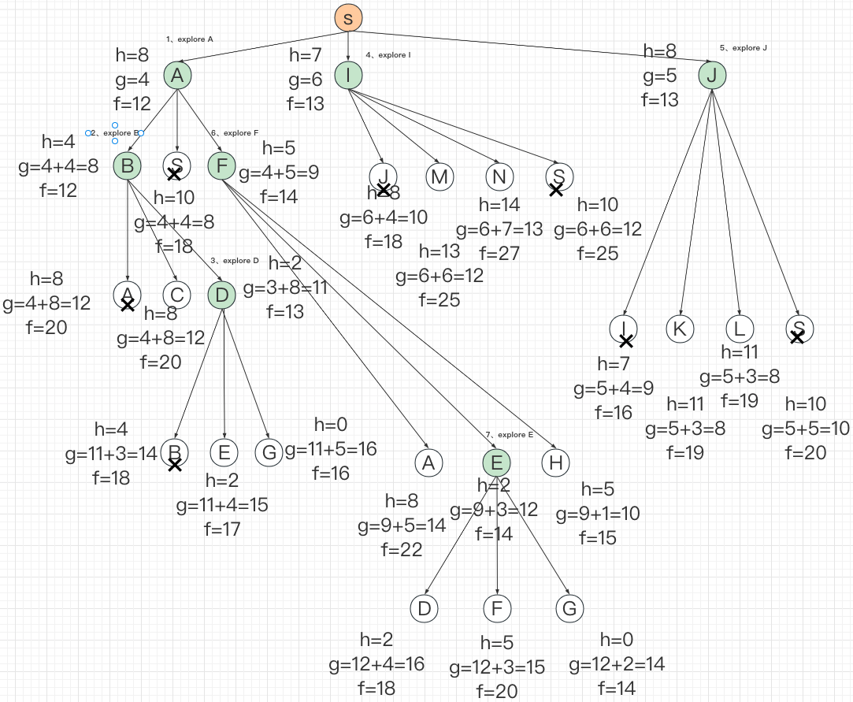

1. [15 pts] Is the given h consistent? Why or why not?

It not consistent.

Because

h(X)=20 ,h(L)=11,cost(x->L)=8

There are instances where h(n)<=c(n,n')+h(n') is not satisfied

1. [20 pts] Design a consistent h\* that dominates all possible consistent heuristics for this

problem. Write the values of h\* for each city.

h(A) = 10

h(B) = 8

h(C) = 12

h(D) = 5

h(E) = 2

h(F) = 5

h(G) = 0

h(H) = 5

h(I) = 20

h(J) = 19

h(K) = 22

h(L) = 22

h(M) = 26

h(N) = 27

h(O) = 29

h(P) = 30

h(Q) = 31

h(R) = 31

h(S) = 14

h(T) = 29

h(U) = 30

h(W) = 29

h(X) = 30

h(Y) = 31

6. [15 pts] Perform A\* search from S to G, using the edge costs given above and your h\* function from question 5. Show the frontier, the explored, and the search tree, as was shown in class. Show the f values clearly in the frontier and in the search tree. What is the solution path found and what is its cost? Compare the tree of Q3 to Q6. Which one is smaller? Could your tree be even smaller and still optimal?

explor sort by ：

S A F E

The best solution path is S-A-F-E-G cost 14

Q6 is smaller

I don't think it can be even smaller or optimized.

The current h function has used the real cost every city from the goal. The current h function should dominate other possible h functions.

